Management Plan
Pine Donkey Orchid

Risk Statement: Low

This document will be reviewed on a five yearly basis, unless a process change occurs earlier than this period, due to monitoring requirements.

Doc No. | Version No. | Next Review Date | Owner
PLN-0064 | 5.01 | 30/06/2025 | Environment ＆ Farms Superintendent

Revision Summary

First Issue | Issue Date | Implementation Requirements | Approved By
1 | 15 Feb 15 | Prepared by R. Feeney for compliance with EA and OEH requirements | Environment and Farming Superintendent

Version No. | Revision Date | Summary of Revision Details | Approved By
2 | 22 Sep 15 | Updated with Comments from OEH by R. Feeney | Environment and Farming Superintendent
3 | 26 Jun 18 | Reviewed by Nathan jones
4 | 26 Feb 20 | Updated to new DCS | M Row
5 | 26 May 20 | Updated to include changes in legislation and annual review | Environment & Farm Superintendent
5.01 | 27 Sep 22 | Updated logo – D Shaw

Consultation Required | Hard Copy Locations
Not Applicable | Northparkes Website

Associated Documents to be Reviewed
Not Applicable

Table of Contents
1. OVERVIEW 5
1.1 Background 5
1.2 Mining Context 5
1.3 Pine Donkey Orchid Species Management 5
2. SCOPE 6
3. PURPOSE / OBJECTIVES 6
4. RESPONSIBILITIES 9
5. DEFINITIONS 11
6. SPECIES INFORMATION 11
6.1 Habitat and Ecology 11
6.2 Known Population and Relationship within the Region 12
6.3 Local knowledge of the species 12
6.4 Recognised threats 16
7. PERFORMANCE INDICATORS 16
7.1 Objectives and indictors 16
8. POTENTIAL IMPACTS 17
8.1 Overview 17
8.2 Clearance of Vegetation/Loss of Habitat 17
8.3 Fragmentation 17
8.4 Edge Impacts 17
8.5 Introduced Species 17
9. MITIGATION AND MANAGEMENT ACTIONS 18
10. MONITORING 20
11. REVIEWS AND CONSULTATION 23
12. ADAPTIVE MANAGEMENT PROCESS 23
13. PERFORMANCE AND COMPLETION CRITERIA 24
14. TRIGGERS FOR ADAPTIVE MANAGEMENT 24
15. COMMUNICATION, TRAINING, REPORTING AND AUDITING 25
15.1 Communication 25
15.2 Site inductions 25
15.3 Project shift change meetings 25
15.4 Internal reporting 25
15.5 External reporting 25
16. REQUIREMENTS UNDER LEGISLATION 26
16.1 Environmental Planning and Assessment Act 1979 26
16.2 Environmental Planning and Assessment Regulation 2000 26
16.3 Biodiversity Conservation Act 2016 26
16.4 New South Wales recovery plan 26
16.5 Development Consent 27
17. REGULATORY REQUIREMENTS 27
18. REFERENCE MATERIALS 29
19. Appendix A 30
19.1 Vegetation Formations, Classes and Types Associated with Pine Donkey Orchid in the Central West Region of NSW 30

OVERVIEW

Background
CMOC Mining Services Pty Limited (CMOC) is the manager of the Northparkes Joint Venture, an unincorporated joint venture between CMOC Mining Limited (80%); Sumitomo Metal Mining Oceania Pty Ltd (13.3%) and SC Mineral Resources (6.7%). Northparkes is a copper-gold operation in Goonumbla, situated 27 kilometres north-west of the town of Parkes.

Construction of the ore processing plant and associated facilities began in 1993. Open cut mining commenced on the E22 and E27 ore bodies in late 1993. Development of the E26 lift 1 block cave underground mine began in 1994, with full scale production commencing in 1997.

Mining Context
Operations at Northparkes primarily comprises underground mining from multiple ore sources that feed a processing plant with a capacity of 6.5 million tonnes per annum (Mtpa). The underground mine is accessed via a decline ramp from the surface for people and materials with ore transported to the surface via inclined conveyors and a hoisting shaft, with a nominal capacity of 7.2 Mtpa. Northparkes utilises low cost block and sub-level cave mining and exploits industry leading technology, such as semi-autonomous loaders and various cave monitoring systems.

The ore processing operation consists of four stages: crushing, grinding, flotation and thickening / filtering. In addition to producing concentrate, the ore processing team also manages tailings disposal. The concentrator was constructed in two modules. Each module consists of its own grinding circuit with a single flotation circuit, concentrate thickener and filter. After extracting the copper and gold bearing minerals, the tailings are combined in a single tailings thickener before being deposited in the active tailings storage facility.

Northparkes’ copper concentrate is transported to a rail siding at Goonumbla where it is then transported by rail to Port Kembla, for shipping to overseas customers.

Pine Donkey Orchid Species Management
Umwelt Australia was commissioned by Northparkes to produce a Biodiversity Offset Management Plan (BOMP) for the Project. As well as outlining management, monitoring and compliance requirements for the Project and offset areas, the BOMP included management and monitoring requirements for two populations of the pine donkey orchid (Diuris tricolor) that occur within the Project Area. Following ongoing consultation with the former Office of Environment and Heritage (OEH), the BOMP for the Project was submitted in December 2014. Following review of the BOMP, OEH requested that Northparkes produce a Species Management Plan (SMP) for known populations of pine donkey orchid. The current document has been produced to comply with this request.

This SMP provides a framework for the management of the populations of pine donkey orchid within Northparkes. This SMP has been prepared to support the overarching Biodiversity Offset Management Plan, which was conditioned under schedule 3, section 29 of the Development Consent.

The pine donkey orchid is listed as vulnerable in New South Wales (NSW) under the Biodiversity Conservation Act 2016 (BC Act). An endangered population of pine donkey orchid is also listed under the BC Act in the Muswellbrook local government area. As this population is located approximately 400 km north-east of Northparkes, it is not relevant to the current species management plan. The pink donkey orchid is not currently listed under the Environment Protection and Biodiversity Protection Act 1999 (EPBC Act).

Ecological surveys for the Environmental Assessment (EA) identified pine donkey orchid within the Project area. Two populations of pine donkey orchid have been identified within the Project area; one population is located to the north of the Step Change Project Area (along Adavale Lane) and the other population is located near the E48 subsidence zone. A total of 1171 plants (234 and 937 respectively) were recorded within the two areas during ecological assessments for the Step Change Project. It is anticipated that a total of 14 individual plants and 0.05 hectares of known habitat will be removed by the Project.

SCOPE
This document applies to all activities undertaken by Northparkes including mining and exploration activities, processing of copper / gold ore resources, project development, maintenance activities, mine closure, logistics, associated service and support functions, bore fields, farming operations and products.

PURPOSE / OBJECTIVES
The objectives of this species management plan for the pine donkey orchid are to:
- Detail actions and procedures for pre-construction, construction and operation phases of the Project in order to mitigate adverse impacts on the pine donkey orchid.
- Manage, monitor and report on the two populations of pine donkey orchid over time in terms of changes in extent, changes in individual numbers and the response of the populations to management actions.
- Facilitate compliance with the development consent conditions as specified by a delegate of the Minister for Planning Industry and Environment under the EP&A Act.
- Facilitate compliance with commitments outlined in the EA
Expand existing knowledge of the life history and ecology of the pine donkey orchid through ongoing reporting to the OEH following monitoring events.
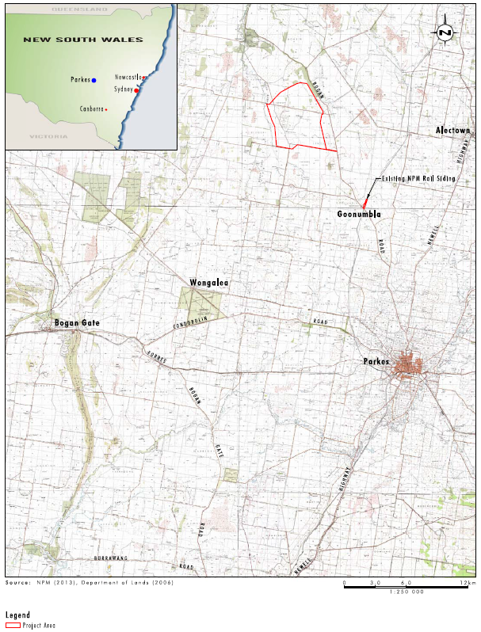

Figure 1: Location of Northparkes Mines in landscape context

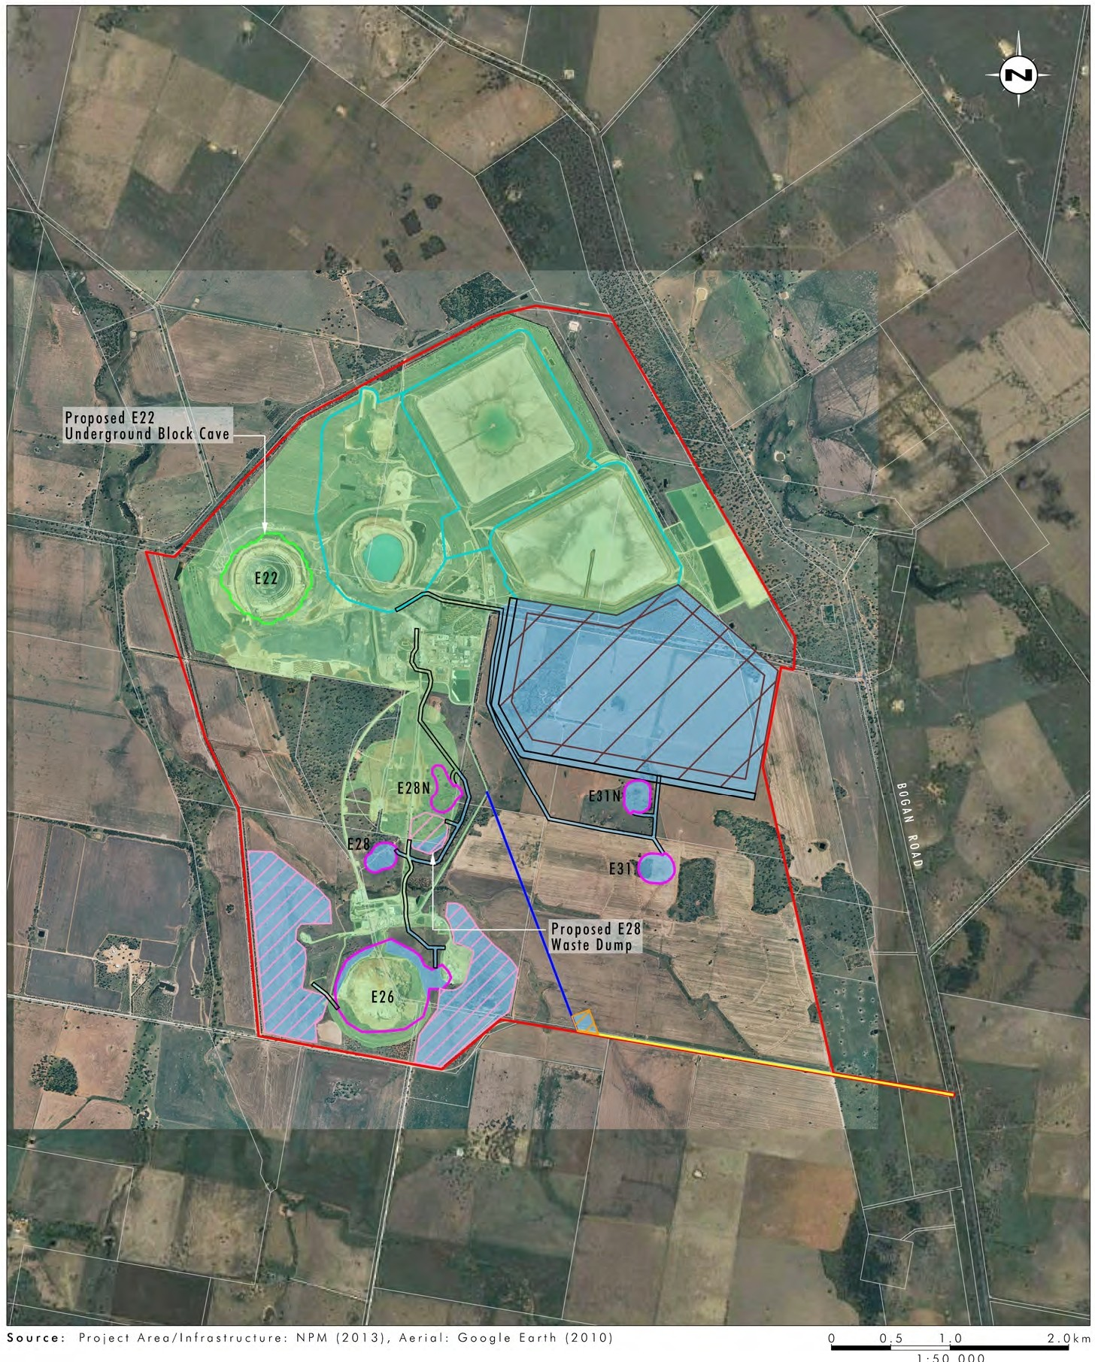
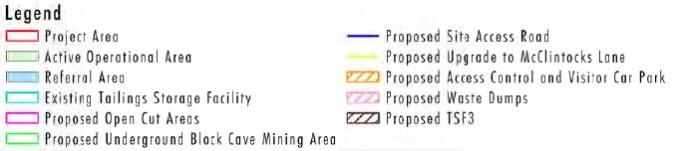

Figure 2: Nortparkes Mines existing and approved operations

RESPONSIBILITIES
General role responsibilities are outlined in the Health, Safety and Environment Responsibilities and Accountabilities Procedure (PRO-0080). Personnel carrying out work under this document must be familiar with and comply with it in full. The following persons have specific responsibility:

Table 1: Responsibilities
Role | Pre-construction | Construction | Operation
CMOC | - create and demonstrate a proactive culture towards HSE at Northparkes  - support and endorse the Health, Safety and Environment (HSE) Policy.  - ensure that adequate resources are available to comply with the HSE Policy.
PSE Manager | - create and demonstrate a proactive culture towards HSE at Northparkes  - ensure adequate resources are available to meet all compliance requirements and implement the actions outlined in this SMP  - ensure that the requirements of this SMP are incorporated into the Project planning process  - ensure all high-level legal requirements are fulfilled prior to construction | - create and demonstrate a proactive culture towards HSE at Northparkes  - ensure adequate resources are available to meet all compliance requirements and implement the actions outlined in this SMP | - create and demonstrate a proactive culture towards HSE at Northparkes  - ensure adequate resources are available to meet all compliance requirements and implement the actions outlined in this SMP
Environment & Farm Superintendent | - ensure adequate resources are available to achieve the requirements of this SMP  - supervise regular audits against performance outcomes and Development Consent requirements  - provide environmental advice and communicate the requirements of this SMP to all employees and contractors associated with the project | - ensure adequate resources are available to achieve the requirements of this SMP  - provide environmental advice and communicate the requirements of this SMP to all employees and contractors associated with the project | - provide environmental advice and communicate the requirements of this SMP to all employees and contractors associated with the project  - ensure adequate resources are available to achieve the requirements of this SMP
Environment Team | - conduct audits against performance outcomes and Development Consent requirements  - provide environmental advice and communicate the requirements of this SMP to all employees and contractors associated with the project  - produce species information profile to distribute to all employees to raise awareness of the pine donkey orchid around site | - assist all employees in achieving environmental compliance  - conduct regular audits against performance outcomes and Development Consent requirements  - provide environmental advice and communicate the requirements of this SMP to all employees and contractors associated with the project  - produce species information profile to distribute to all employees to raise awareness of the pine donkey orchid around site  - ensure that construction works are conducted in line with this SMP | - assist all employees in achieving environmental compliance  - provide environmental advice and communicate the requirements of this SMP to all employees and contractors associated with the project  - conduct regular audits against performance outcomes and Development Consent requirements  - produce species information profile to distribute to all employees to raise awareness of the pine donkey orchid around site  - ensure that construction works are conducted in line with this SMP
All personnel | - demonstrate a proactive culture towards HSE at Northparkes  - work with the Environment team to achieve positive environmental outcomes | - demonstrate a proactive culture towards HSE at Northparkes  - work with the Environment team to achieve positive environmental outcomes | - demonstrate a proactive culture towards HSE at Northparkes  - work with the Environment team to achieve positive environmental outcomes

DEFINITIONS
Table 2: Definitions
Key Word | Definition
ALA | Atlas of Living Australia
BC Act | Biodiversity Conservation Act 2016 (New South Wales)
BGT | Botanic Gardens Trust
BOMP | Biodiversity Offset Management Plan
BOS | Biodiversity Offset Strategy
CMA | Catchment Management Area
CMOC | China Molybdenum Co. Ltd
DECC | Department of Environment and Climate Change
DoPIE | Department of Planning, Industry and Environment
DotE | Department of the Environment
EA | Environmental Assessment
EOI | Expression of Interest
EP&A Act | Environmental Planning and Assessment Act 1979
EP&A Reg | Environmental Planning and Assessment Regulation 2000
EPBC Act | Environment Protection and Biodiversity Act 1999 (Commonwealth)
NSW | New South Wales
OEH | Office of Environment and Heritage
SMP | Species Management Plan
TSF | Tailings Storage Facility
The Project | Northparkes Mine Extension Project
Umwelt | Umwelt Environmental Consultants

SPECIES INFORMATION

Habitat and Ecology
The pine donkey orchid is a slender to relatively robust terrestrial orchid, which grows annually from an underground tuber (Cunningham et al., 1992). This species has a single stem to approximately 40 cm high, where is has 2- 6 flowers. Flowers are bright yellow to orange, speckled with red to purple and white markings (OEH, 2014) (Figure 3). This species has one to three leaves, which are to 20 cm long and 4 mm wide. The sepals of the pine donkey orchid are very long and often crossed (OEH, 2014). This species fruits a capsule containing many minute seeds and flowers in spring (Cunningham et al., 1992).

The pine donkey orchid can be found in a range of habitats, where it is often associated with white cypress pine (Callitris glucophylla), Poplar box (Eucalyptus populnea) and gum coolabah (Eucalyptus intertexta) as well as ironbark and acacia shrubland (OEH, 2014). This species often occupies grassy understories with herbaceous plants, such as bulbine species. Pine donkey orchid is also know to grow in sclerophyll forest among grass, often with Callitris species (OEH, 2014). When this species is detected, it is usually recorded as common to locally frequent in populations; however, this species has also been known to occur as single plants (OEH, 2014).

OEH has summarized vegetation associated with pine donkey orchid within for Central West region (as defined under the BioMetric Native Vegetation Assessment Tool). For a list of vegetation associated with the pine donkey orchid refer to Appendix A – Vegetation Formations, Classes and Types Associated with Pine Donkey Orchid in the Central West Region of NSW

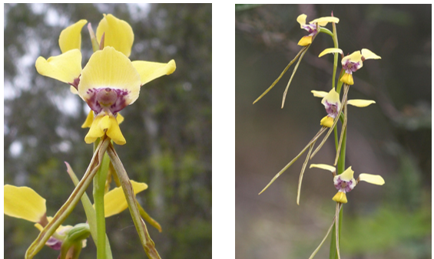
Figure 3: Pine donkey orchid flower (left) and habit (right) (Plantnet, 2015)

The pine donkey orchid occurs along the east of Australia, where it predominately occurs in NSW, but has also been recorded in Queensland and northern Victoria (ALA, 2014). This species is sporadically distributed on the western slopes of NSW, extending from south of Narrandera to northern NSW.

Known Population and Relationship within the Region
Known populations of pine donkey orchid in the central west region of NSW occur along Condobolin-Nymagee road, in Wattamondara towards Cowra, Eugowra, Girilambone, Dubbo and Cooyal (OEH, 2014). OEH has summarized the known and predicted distribution of pine donkey orchid for the Central West region of NSW; for a list by catchment management area (CMA) sub-region, refer to Table 3

Table 3: Known or predicted occurrence of pine donkey orchid by CMA sub-region
CMA Sub-region | Know or Predicted Occurrence | Graphic restrictions
Bogan- Macquarie | Known | None
Canbelego Downs | Known | None
Lower Slopes | Known | None
Nymagee-Rankins Springs | Known | None
Pilliga | Known | None
Pilliga Outwash | Predicted | None
Talbragar Valley | Known | None
Upper Slopes | Known | None

Additionally, pine donkey orchid is known to occur within the Northparkes mining lease and surrounding area, with one population occurring north of Northparkes and a second population occurring near E48 subsidence area within the Project Area.

Local knowledge of the species
Several ecological surveys have been undertaken across Northparkes. Flora surveys undertaken for the EA and baseline monitoring surveys for the pine donkey orchid are outlined in the following sections.

Flora field surveys for the EA
The pine donkey orchid was first recorded within the Project area during surveys for the EA. Flora surveys for the EA are outlined below:
- 27 and 28 July 2011 – rapid vegetation surveys undertaken by two ecologists (Umwelt)
- 26 to 30 September 2011 - Rapid vegetation surveys, systematic plot-based surveys and targeted threatened flora searches undertaken by two ecologists (Umwelt)
- 30 January to 3 February 2012 - Rapid vegetation surveys, systematic plot-based surveys and targeted threatened flora searches undertaken by two ecologists (Umwelt)
- 15 to 19 May 2012 - Rapid vegetation surveys, systematic plot-based surveys and targeted threatened flora searches, undertaken by two ecologists (Umwelt)
Total flora survey effort undertaken for the EA is outlined in Table 4 below:

Table 4: Flora survey effort summary
Flora survey technique | Wider study area | Project area | Proposed disturbance area
Floristic quadrats | 34 | 19 | 3
Semi quantitative rapid assessment points | 60 | 18 | 1
Qualitative rapid assessment points | 365 | 76 | 12
Meandering transects and field reconnaissance | 151 km of walking and 526 km of driving

Targeted threatened flora searches were completed across areas of suitable habitat throughout the Wider Study Area for the pine donkey orchid. Additionally, targeted seasonal surveys for the pine donkey orchid were conducted over only a small portion of the proposed disturbance area. Prior to conducting targeted surveys, the flowering status of this species was verified using a known population at Dubbo as a reference site. It was confirmed the week prior to the spring 2011 surveys that this species was in full flower.

The targeted threatened flora searches were variable in length and location, and were tailored to suit the environment in which they occurred to gain maximum coverage of likely habitat for potential threatened flora species. A meandering technique was selected over the plot-based method since the amount of replicate plots that could have been sampled within each vegetation unit was limited by a restricted survey time. The meandering technique within each search area increased the amount of data that could be collected within the available survey time, thereby maximising the quality and coverage of vegetation description and mapping. Targeted threatened flora searches are useful for detecting threatened flora species across large areas, as they enable the surveyor to cover large proportions of the area under investigation, unlike plot-based surveys.

Results of the flora field surveys for the EA
During field surveys for the EA, one population of pine donkey orchid was recorded within the wider study area. The population of pine donkey orchid was recorded within a patch of White Cypress Pine Woodland along the northern boundary of the Project Area (approximately 2.5 kilometres north of the proposed disturbance area). The population extended north, across the realigned section of Adavale Lane, into a larger patch of White Cypress Pine Woodland within the Wider Project Area. A total of 234 plants were recorded within the two areas, a majority of which occur outside of the Project Area.

No patches of White Cypress Pine Woodland occur within the Proposed Disturbance Area, however suitable habitat for the species remains present. Particularly in open areas of the Grey Box Woodland where white cypress pine is locally dominant. Habitat also occurs, albeit in small areas, within the Adavale Lane and McClintocks Lane road reserves. Additional areas include the woodland north of the E26 existing subsidence area.

Results of the targeted pine donkey orchid surveys undertaken in 2013
In response to comments from OEH, targeted surveys for the pine donkey orchid were undertaken in spring 2013. During these target survey, 947 individual pine donkey orchid plants were recorded in the Project Area and the approved E48 subsidence zone.

Baseline monitoring surveys for the pine donkey orchid
Following identification of the pine donkey orchid within the wider project area during surveys for the EA, baseline monitoring surveys were undertaken in spring 2014, to coincide with the flowering period. Survey of two populations of the pine donkey orchid associated with the Northparkes Mine project area were carried out on 11 and 14 November 2014. Populations were surveyed within the following two pine donkey orchid Management Zones:
- E48 Subsidence Zone.
- Adavale Lane.
The locations of these management zones are shown in Figure 4.

Survey comprised marking the locations of each individual plant encountered along walking transect, using a GPS-generated point. Transects were generally between 5 and 10 metres apart to achieve comprehensive spatial coverage of each population, with the aim of locating every individual orchid visible.

Results of baseline monitoring surveys for the pine donkey orchid
One hundred and ninety-nine individual pine donkey orchids were recorded in the two pine donkey orchid Management Zones surveyed in spring 2014. These included:
- 69 individual plants in E48 Subsidence Zone; and
- 130 in Adavale Lane.
Far fewer pine donkey orchids were recorded during baseline surveys in 2014 (199 individuals), compared to the target surveys undertaken in 2013 (947 individuals), and this result may have been due to a number of factors. Although surveys were carried out within the typical peak flowering period for pine donkey orchid, withering of the flowers on a number of the plants was observed, which may be attributable to the hot, dry conditions experienced in the Northparkes area in the week preceding survey. This may have reduced the total count of plants recorded during survey since the plant is more difficult to see when open flowers are absent. Additionally, as the pine donkey orchid has a narrow flowering period between September and late October/November, surveys undertaken during 2014 may have been at sub optimal time compared to surveys taken in 2013. As this species is only detectable during flowering, this may have contributed to the reduced population count. As there is limited academic literature on the ecology of this species, ecological and external factors, such as climatic conditions and flowering ecology of this species (such as if all plants flower annually) may have also contributed to the reduced number of the pine donkey orchid plants recorded in 2014 compared to 2013. However, it is likely that the majority of plants present during survey were recorded.

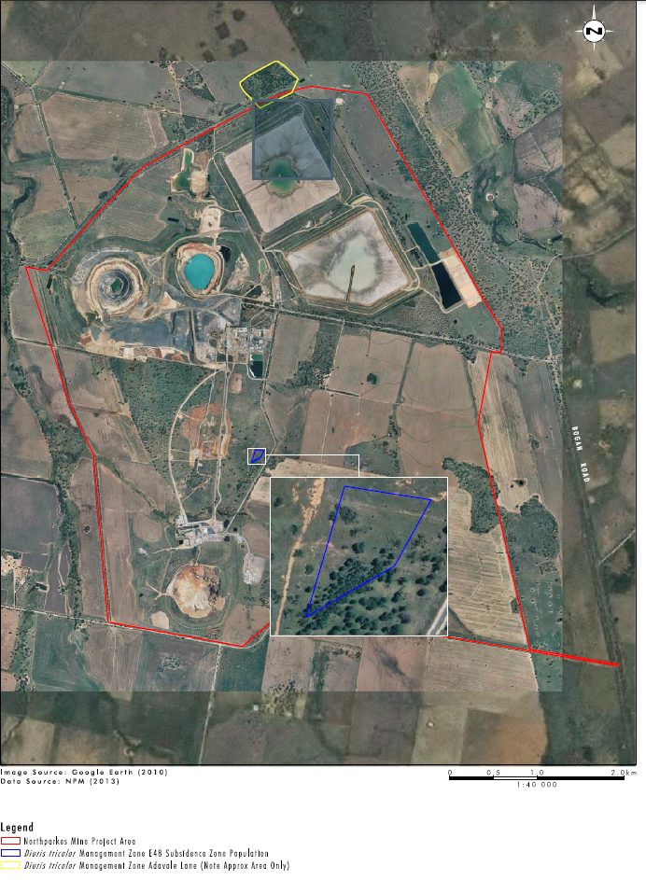
Figure 4: Pine donkey orchid management zones

Recognised threats
Many orchids are inherently rare or locally restricted (Swarts and Dixon, 2010). Because this rarity is often coupled with a mycorrhizal symbiosis between the root system of the orchid and the soils fungi and/ or animal pollination for survival, many species of orchid are susceptible to population decline (Merritt et. al., 2014).
The pine donkey orchid is threatened by the following processes in NSW:
- Habitat clearing, fragmentation and/ or modification - Construction of the Project will require clearing of areas of suitable habitat for the pine donkey orchid. Additionally, construction works may result in increased habitat fragmentation and/ or alternation. This species requires a grassy ground layer to provide some protection and moisture retaining litter (OEH, 2014).
- Low detectability –This species only flowers for a short period in spring, from September to November (Plantnet, 2015) and it is extremely difficult to identify outside of the flowering period. Low detectability may result in some plants going undetected if ecological surveys or pre-clearance assessments are undertaken outside of the flowering period (OEH, 2014).
- Feral animals - suitable habitat for the pine donkey orchid (consisting of open woodlands or grasslands with Callitris species) are susceptible to disturbance from introduced species including foxes, rabbits and hares (OEH, 2014).
- Weed competition - Increases habitat fragmentation and vehicle traffic may increase weed competition in areas of suitable habitat (OEH, 2014).
- Overgrazing – As the pine donkey orchid is a terrestrial species that occurs in open woodlands and grasslands, this species may be susceptible to grazing pressures from large numbers of introduced (cattle, sheep, rabbits, hares etc.) and native herbivores (macropods).
- Illegal collection – As orchids are desirable in gardens they are prone to illegal collection.
As well as the recognised threats for the pine donkey orchid listed above, orchid germination can also be suppressed through competition with other ground layer species, in particular dense growth of native grasses. Additionally, there is a large population of macropods that inhibit the Northparkes Miens lease area, which may inhibit the growth of this species through grazing.

PERFORMANCE INDICATORS

Objectives and indictors
The environmental objectives that have been developed for this SMP have been tailored to the environmental values of the populations of pine donkey orchid within and surrounding Northparkes and the potential impacts on this species. The performance objective for this SMP includes:
- That habitat values for the two populations of pine donkey orchid are maintained and enhanced where possible,
- The management of the two populations of pine donkey orchid within and surrounding Northparkes, as well as the management of areas offsite (including offset areas) will contribute to the recovery actions outlined in the Saving our Species Program including:
  - Conduct baseline surveys to locate new populations and extend the ranges of currently known populations.
  - Annually monitor populations that represent the spatial distribution of the species.
  - Erect stock-proof fences around populations that are highly threatened from trampling and grazing by stock.
  - Develop a fact sheet and distribute to employees and contractors to increase knowledge of the species
  - Investigate culling kangaroo populations to reduce grazing pressure on pine donkey orchid.
The following indictors will be used to monitor the success of this SMP in achieving its objectives:
- An annual audit demonstrating implementation of the mitigation and management measures
- No net decline in the population of pine donkey orchid within the two management zones
- Evidence of natural germination of pine donkey orchid within the two management zones
- No net increase of weed species that reduced the habitat value for pine donkey orchid.

POTENTIAL IMPACTS

Overview
The following sections outline the potential impacts to the pine donkey orchid as a result of the project. The summary of impacts is based on impacts identified for the Project for the impact assessment in the EA that are of relevance to the pine donkey orchid.

Clearance of Vegetation/Loss of Habitat
The clearing of vegetation will comprise the main impact of the Project. This impact will come from the direct removal of vegetation (including constituent flora and potentially donkey pine orchid). The potential impacts of the clearance of vegetation/loss of habitat are to be mitigated for pine donkey orchid by conducting pre-clearance surveys prior to tree felling. The potential residual impacts will be mitigated via a biodiversity offset strategy (BOS) to secure, manage and improve appropriate habitat areas.

Fragmentation
The clearing of vegetation within the proposed disturbance area will increase the levels of fragmentation in the local area. Increased isolation and fragmentation results from a reduced gene flow throughout the landscape. Limited genetic flow into or out of a particular area can lead to reduced genetic variation and inbreeding depression within flora species. This can lead to isolated populations being placed at increased risk of local extinction due to a reduced ability to cope with stochastic events and environmental change.

Edge Impacts
Many native species are known to be sensitive to edge-effects. Such edge effects result in the deterioration of the quality of vegetation along the interface with cleared or disturbed environments. Such habitat deterioration can result from impacts such as increased weed invasion, rubbish dumping, increased predation, increased presence of introduced species or increased human presence. Edge effects from the Project could include minor weed issues, pest species movements, noise, light and dust.
There is a potential that edge effects as a result of the Project may have some marginal impacts on adjoining areas. The design of the Project includes measures to minimise the potential for air quality, fugitive light and noise impacts. However, edge effects are unlikely to significantly affect the ecology of the adjoining areas. The potential impacts from edge effects are managed via ongoing weed and feral animal control.

Introduced Species
Importation of materials to the proposed disturbance area, management activities, increased human presence and clearing of vegetation all have the potential to increase the incidence of introduced species within the proposed disturbance area. Weed species may be inadvertently brought into the proposed disturbance area with imported materials, or encouraged by removal of native vegetation. An increase in introduced species within the proposed disturbance area could have considerable impacts on existing native species. Introduced species are to be managed via weed and feral animal control programs.

MITIGATION AND MANAGEMENT ACTIONS
Management and mitigation measures will be implemented for the life of the Project. Management actions will seek to maintain and where possible, enhance the habitat for, and increase the populations of pine donkey orchid.

Key management actions that will be implemented to specifically mitigate impacts on the populations of pine donkey orchid during pre-construction, construction and operation of the Project include:
- fencing of the populations to remove potential impacts from human access (particularly vehicle access) prior to works commencing;
- annual seasonal monitoring during the flowering period (September to October) to assess the ongoing status of the population;
- annual monitoring of ground cover abundance and flora species composition;
- weed monitoring and control, as required. All weed control actions will be undertaken outside the flowering period of the species;
- educating staff through inductions and People, Safety and Environment meetings, with flora and fauna management included as a topic;
- the environment team will work to implement flora and fauna management throughout the planning, construction and operation phases of the project.
Other general management and mitigation measures that will be implemented to minimise potential impacts to the populations of pine donkey orchid during pre-construction, construction and operation are outlined in Table 5.

Table 5: Management and mitigation measures
Issue | Control | Responsibility | Project phase | Timeframe | Documentation
General | Establish ongoing monitoring program for the populations of pine donkey orchid | Environment & Farm Superintendent | Pre-construction | Complete | BOMP, SMP for pine donkey orchid, Annual monitoring reports
 | Undertake annual monitoring of pine donkey orchid populations. Monitoring is to be undertaken during spring, when this species most detectable (flowering). | Environment & Farm Superintendent | Pre-construction, Construction, Operation (as required) | Ongoing. Once annually | BOMP, SMP for pine donkey orchid, Annual monitoring reports
 | Provide information on the pine donkey orchid for inclusion in site training modules. Information will outline threatened status, general ecology and habitat preferences, flowering time and timeframe for detectability and a photo to aid identification if this species is seen during works. | Environment & Farm Superintendent | Pre-construction, Construction, Operation | Prior to site access | Basic environemtnal awreness training module
 | Discuss ecological considerations, including the pine donkey orchid in shift change meetings, particularly during clearing works | Environment & Farm Superintendent , Project Manager | Pre-construction, Construction, Operation | Ongoing | SMP for the pine donkey orchid
 | Be aware of requirements of this SMP for the pine donkey orchid during all works for the Project. If pine donkey orchid is identified during clearing work, suspend works and contact the Environment team. | All Northparkes staff and contractors | Pre-construction, Construction, Operation | Ongoing | BOMP, SMP for pine donkey orchid, Annual monitoring reports, Basic environemtnal awreness training module
 | Establish fences around known populations of pine donkey orchid to restrict human disturbance. | Environment & Farm Superintendent | Pre-construction | Prior to construction | SMP for the pine donkey orchid.
Clearing of vegetation/ loss of habitat | Undertake pre-clearance surveys prior to vegetation clearing | Environment & Farm Superintendent | Pre-construction | Prior to construction | Development Consent for the Project, Pre-clearance report
 | Have ecologist oversee tree-felling works for areas identified as Grey Box Grassy Woodland or potential habitat for the pine donkey orchid | Environment & Farm Superintendent | Construction | During construction | Development Consent for the Project, Pre-clearance report. Northparkes tree felling procedure
 | Maintain a data set of the location of known pine donkey orchid populations, including GPS points of all known individual plants | Environment & Farm Superintendent | Pre-construction, Construction, Operation | Ongoing | Annual monitoring reports
 | Undertaken rehabilitation and weed management in areas not directly impacted by the project to improve the quality of habitat in these areas | Environment & Farm Superintendent | Pre-construction, Construction, Operation | Ongoing | BOMP
 | Clearly identify the extent of vegetation clearing on construction plans and in the field. Clearing extents will be communicated to all necessary construction supervisors | Project Manager | Construction | Prior to construction | Project maps and technical drawings
Fragmentation and edge effects | Minimise the extent of proposed new roads during Project planning | Project Manager | Preconstruction | Project planning phase | Project maps and technical drawings
Introduced species | All staff are to drive on designated roads to limited weed spread and damage to vegetation. | All staff | Pre-construction, Construction, Operation | Ongoing | Project maps and technical drawings

MONITORING
Annual monitoring of the known populations of the pine donkey orchid will be undertaken. The aims of this monitoring is to:
- assess the ongoing status of the population; and
- identify any threats to the population such as weed invasion.
The following monitoring activities will be undertaken:
- Both populations will be fenced to remove potential impacts from human access (particularly vehicle access) prior to works commencing. Along Adavale Lane the extent of the population that occurs within Northparkes landholdings will be fenced. Areas along the Adavale Lane road reserve where the species occurs will not be fenced (Figure 5). Near the E48 subsidence zone the population outside of the haul road buffer zone will be fenced (Figure 6). The fences will be inspected annually to ensure that disturbance by humans or grazers has been prevented.
- Prior to the construction of the road, all construction personnel will be briefed on the presence and location of pine donkey orchid and made aware of the importance of minimising disturbance in this area via inductions.
- Annual seasonal monitoring during the flowering period (September to October) to assess the ongoing status of the population will be undertaken. The location of all individuals are to be recorded using a hand held GPS and a total count is to be provided for each population.
- Annual monitoring of ground cover abundance and flora species composition using permanent five × five metre floristic plots will be undertaken. Three five × five metre plots floristic plots will be established at the Adavale Lane population and another three at the E48 population. The plots will be positioned to measure the species composition and cover abundance of ground covers in the population areas.
- Weed monitoring via walking meandering transects through both populations, and where required weed control. All weed control actions will be undertaken outside the flowering period of the species.
Following each monitoring event, a report will be produced outlining the outcomes. This report will be supplied to OEH.

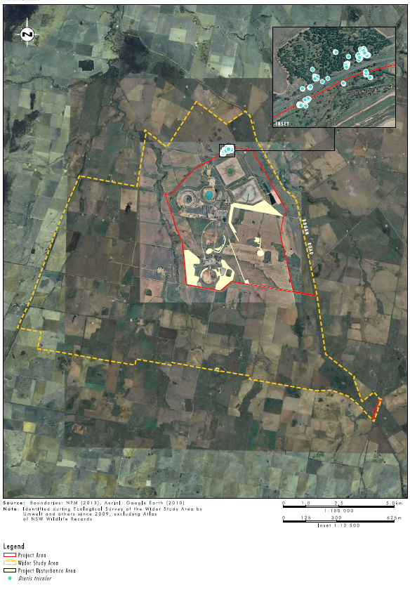
Figure 5: Pine donkey orchid populations at Avadale Land

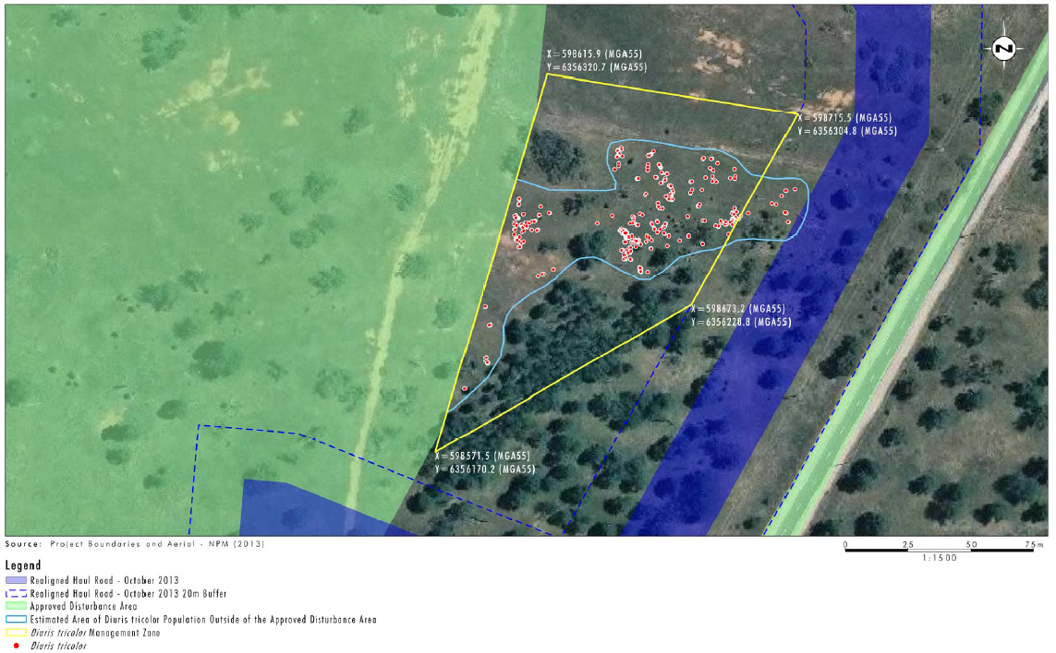
Figure 6: Pine donkey orchid population at the E48 subsidence zone

REVIEWS AND CONSULTATION
This SMP will be reviewed annually to:
- refine and make improvements to the management strategies; and
- assess the performance of the management strategies against preliminary performance indicators and completion criteria.
The review will look for opportunities to improve the management strategies as well as further develop and forecast the longer term performance indicators and completion criteria. Adaptive management amendments to this SMP that are made for continual improvement do not require submission to the relevant authorities for approval if they are consistent with the conditions of the Development Consent.

Northparkes will consult with the Department of Planning, Industry and Environment (DoPIE) regarding the implementation this SMP.

ADAPTIVE MANAGEMENT PROCESS
Adaptive management of this SMP will be responsive to any new and relevant data that may arise through the monitoring of the pine donkey orchid populations, legislative change or any other studies completed at the site. This will enable a flexible approach to management commitments, allowing ongoing feedback and refinement of this SMP. Adaptive management will be a key mechanism to address the risks to the successful implementation of this SMP. Adaptive management steps include regular review of this SMP, including adaptation of targets and performance indicators, recognising potential risks to the successful implementation of this SMP and having a frame work in place for corrective actions.

The adaptive management process is outlined in Figure 7.

Figure 7: Adaptive management process

PERFORMANCE AND COMPLETION CRITERIA
Performance and completion criteria for the orchid populations are provided in Table 6.

Table 6: Avadale Lane and E48 subsidence zone pine donkey orchid populations performance and completion criteria
Action | 2014 Baseline | Years 1 to 5 PC 2015 to 2019 | Years 8, 11, 14, 17 & 20 PC | Completion criteria
Erect fence | Completed |  |  | Completed
Fence inspections |  | To be completed annually for the first 5 years | To be completed every 3 years after year 5 | Ongoing
Annual orchid monitoring during flowering period | Completed | To be completed annually for the first 5 years | To be completed every 3 years after year 5 | Ongoing
Ground cover monitoring |  | To be completed annually for the first 5 years | To be completed every 3 years after year 5 | Ongoing
Weed monitoring | Completed | To be completed annually for the first 5 years | To be completed every 3 years after year 5 | Onggoing

TRIGGERS FOR ADAPTIVE MANAGEMENT
Trigger points for adaptive management of the pine donkey orchid populations are provided in Table 7.

Table 7: Avadale Land and E48 subsidence zone pine donkey orchid populations’ triggers for adaptive management
Action | Trigger Point for Adaptive Management | Adaptive Management
Orchid fence inspections | Failure of fence allows humans or grazers to enter the orchid populations | Repairs undertaken
Annual orchid monitoring | Population count declines by 50 per cent from annual average | Review climatic conditions, is the decline due to seasonal conditions.  Review ground cover monitoring results. Have native species prevented emergence?  Review weed monitoring results. Have weed species prevented emergence?  Develop strategies to ensure declining population count is not related to ground cover management or potential disturbances
Ground cover monitoring | Total native ground cover abundance scores increase as the number of orchids declines over 2 years of monitoring. | Identify native ground cover species that have increased in cover abundance as the orchid population has declined. Remove the identified species by hand during the non-flowering season, or as a minimum reduce the identified species to pre orchid decline cover abundance values.
Weed monitoring | Weed species (individually or combined) cover 10 per cent or more of the extent of the population. | Weed species controlled during non-flowering periods by spraying or manual removal.

Results of the pine donkey orchid monitoring will be documented in a monitoring report, along with any management actions required such as weed management.

COMMUNICATION, TRAINING, REPORTING AND AUDITING

Communication
The requirements of this species management plan for the pine donkey orchid will be communicated to all Northparkes staff and contractors involved with the Project. The Project manager will work with the Northparkes environment team to communicate the general intent, scope and relevance of this document to all Northparkes staff and contractors working on the Project. Communication channels will include:
- Environmental training packages
- Construction project pre-start meetings
- Level 2 risk assessments (where relevant)
- Management meetings; and
- Environmental reports.

Site inductions
All personnel who undertake work at Northparkes must complete the basic environmental training module. Information about the pine donkey orchid will be included in the training module to raise awareness of the presence of this species. Information will include threatened status, general ecology and habitat preferences, flowering time and timeframe for detectability and a photo to aid identification if this species is seen during works. Inductees will be advised to contact the Northparkes Environment team if they suspect the presence of pine donkey orchid, and stop work until the species identification can be confirmed.

Project shift change meetings
At the commencement of each work shift, shift change meetings will be undertaken with contractors and staff to communicate relevant environmental considerations for the shift. Of particular importance, will be when works commence in a new location or new activities will be undertaken. Information relevant to works from the SMP will be communicated, including:
- Sensitive environmental areas in proximity to where works are being undertaken,
- Any mitigation and management measures that are relevant to works
- Recent environmental incidents and the corrective actions that are being undertaken.

Internal reporting
During construction and operation of the Project, the following environmental reporting, relevant to this species management plan for the pine donkey orchid, will be undertaken:
- Internal and external environmental audits
- Environmental incident reports
- Monitoring reports for the pine donkey orchid
- Monthly reports

External reporting
Consultation with DoPIE will occur, as required, throughout pre-construction, construction and operation of the Project in relation to management of the populations of pine donkey orchid. Additionally, DoPIE will be provided with a copy of monitoring reports produced following surveys of the pine donkey orchid populations. DoPIE will be contacted if any additional populations of pine donkey orchid are discovered at Northparkes or if any advice is sort regarding the known populations of pine donkey orchid at Northparkes.

The objectives for this management plan will be reported in the Annual Review which includes results of any monitoring undertaken, reporting against the performance objectives and findings from the inspections and audits.

REQUIREMENTS UNDER LEGISLATION

Environmental Planning and Assessment Act 1979
The EP&A Act governs land-use planning and development in NSW. The Act provides for the proper management, development and conservation of natural and artificial resources for the purpose of promoting the social and economic welfare of the community and the environment. The Act provides protection of the environment, including the protection and conservation of native animals and plants, including threatened species, populations and ecological communities and their habitats. The Act also allows for the assessment of project applications and provides for increased opportunity for public involvement and participation in environmental planning and assessment. The EP&A Act is administered by the Department of Planning, Industry and Environment in NSW.

Environmental Planning and Assessment Regulation 2000
The Environmental Planning and Assessment Regulation 2000 (EP&A Reg) is under the EP&A Act. The EP&A Reg aids the EP&A Act by providing further details of the development consents and requirements.

Biodiversity Conservation Act 2016
In New South Wales, threatened species are managed under the Biodiversity Conservation Act 2016 (BC Act), which is administered by the DoPIE. The BC Act provides for the conservation of threatened species, populations and ecological communities of animals and plants (OEH 2014). The Act sets out a number of specific objects relating to the conservation of biological diversity and the promotion of ecologically sustainable development. Threatened species, ecological communities and key threatening processes are identified and classified by a scientific committee and are listed on the schedules of the BC Act.

New South Wales recovery plan

Saving our Species program
Saving our Species is a new conservation program that aims to maximise the number of threatened species that can be secured in the wild in NSW for 100 years. Under the NSW Saving our Species Program, the pine donkey orchid is assigned to the keep-watch species management stream (OEH, 2014). Species in this management stream are considered either naturally rare, have few known threats, or are more abundant than previously assumed (OEH, 2014). This allocation was made as this species is predicted to be secure in NSW for 100 years without targeted management at particular sites. Under the Saving our Species Program, a number of state-wide management actions have been identified for pine donkey orchid, including:
- Conduct baseline surveys to locate new populations and extend the ranges of currently known populations. Surveys should include all State Forests where suitable habitat occurs.
- Following surveys, assess the current conservation status and prepare & submit a nomination for de-listing if required.
- Annually monitor at least 5 populations that represent the spatial distribution of the species.
- Collect seed and soil for NSW Seedbank. Develop collection program (including mycorrhizal symbiont) in collaboration with BGT - multiple provenances.
- Conduct experimental trials into the effects of fire, grazing and weed disturbances.
- Erect rabbit, goat and stock-proof fences around populations that are highly threatened from trampling and grazing by feral animals and stock.
- Develop a fact sheet and distribute via community newsletters, regional shows and field days and by promoting the DEC threatened species website.
- Conduct surveys and assessments of less known sites to confirm presence of species and develop and implement conservation management agreements with landholders for high priority sites.
- Develop an Expression of Interest (EOI) for incentives targeted towards private landowners to locate new sites for conservation.
- Investigate seed viability, germination, dormancy and longevity (in natural environment and in storage) (+ symbionts and soil for orchids, gentians) (OEH, 2014)

Development Consent
In 2013, Northparkes proposed the Step Change Project, which encompassed the continuation of underground block cave, additional campaign open cut mining located in existing mining leases, augmentation to approved Tailings Storage Facilities (TSFs) and an extended mine life until 2032. Associated with the extension to mining operations is the development of supporting surface infrastructure related to amended access and tailings/ waste material storage.

Commonwealth
Following referral to the Commonwealth government, the Step Change Project was assessed as a controlled action under the Environment Protection and Biodiversity Act 1999 (EPBC Act), requiring assessment by Preliminary Documentation on 21 May 2013. The Preliminary Documentation for the Step Change Project included supplementary information on the superb parrot, avoidance and mitigation measures, proposed offsets and residual impacts. The final Preliminary Documentation for the Step Change Project was submitted to the Department of the Environment (DotE) in November 2013. The Step Change Project was approved with conditions by the DotE under the EPBC Act on 13 February 2014. Conditions attached to the approval addressed avoidance and mitigation impacts onsite, offsetting of residual impacts, reporting and auditing, revisions and publications of plans.

New South Wales
In New South Wales (NSW), the Step Change Project was assessed under Section 75J of the Environment Planning and Assessment Act 1979 (EP&A Act). Following submission of the Step Change Project’s Environmental Assessment (EA), the Project was approved with conditions by a delegate of the minister under the EP&A Act on the 16 July 2014. Project conditions for biodiversity related predominately to the population of pine donkey orchid, the securing and management of biodiversity offsets, the securing of a conservation bond and requirements regarding the preparation and implementation of a Biodiversity Offset Management Plan (BOMP).

Following review of the Step Change Project, the scope was altered and project modifications were submitted to the relevant government agencies. The Northparkes Mines Extension Project (the Project) was approved with conditions on 16 July 2014.

REGULATORY REQUIREMENTS
As the pine donkey orchid is listed as vulnerable under the Biodiversity Conservation Act 2016, and is not listed under the EPBC Act, conditions relating to this species are added under the NSW Development Consent for the Northparkes Step Change Project. The Species Management Plan for the pine donkey orchid addresses DC11_0060, Schedule 3, Condition 25 and 29.

The details of the NSW conditions and reference to where they are addressed in the BOMP or SMP for the pine donkey orchid are provided in Table 8.

Table 8: Legal Requirements
Development Consent 11_0060 | Northparkes Reference
Biodiversity
24. The Proponent shall actively manage and maintain the populations of Pine Donkey Orchid located to the north of the project area (near Adavale Lane) and near the E48 subsidence zone. | Entire SMP for the Pine Donkey Orchid.
29. The Proponent shall prepare and implement a Biodiversity Management Plan for the project to the satisfaction of the Secretary. This plan must:  - be prepared in consultation with BCD, and submitted to the Secretary for approval prior to the commencement of any development on site;  - describe the short, medium, and long term measures that would be implemented to:  - manage the remnant vegetation and fauna habitat on the biodiversity offset sites;  - restore the derived native grassland component of the Grey Box Grassy Woodland EEC community within the Kokoda Biodiversity Offset to woodland community;  - implement the biodiversity offset strategies; and  - integrate the implementation of the biodiversity offset strategies to the greatest extent practicable with the rehabilitation of the site (where relevant);  - include detailed performance and completion criteria for evaluating the performance of the biodiversity offset strategies, and triggering remedial action (if necessary);  - include a detailed description of the measures that would be implemented for:  - enhancing the quality of existing vegetation and fauna habitat in the biodiversity offset areas, including the derived native grassland component of the Grey Box Grassy Woodland EEC community within the Kokoda Biodiversity Offset;  - creating native vegetation and fauna habitat in the biodiversity offset areas and rehabilitation area through focusing on assisted natural regeneration, targeted vegetation establishment and the introduction of naturally scarce fauna habitat features (where necessary);  - managing and maintaining the populations of Pine Donkey Orchid located to the north of the project area (near Adavale Lane) and near the E48 subsidence zone (refer to Appendix 6);  - collecting and propagating seed;  - managing any potential conflicts between the proposed enhancement works in the biodiversity offset areas and any Aboriginal heritage values (both cultural and archaeological) in these areas;  - managing salinity;  - controlling weeds and feral pests;  - controlling erosion;  - managing grazing and agriculture on site;  - controlling access; and  - bushfire management;  - include a seasonally-based program to monitor and report on the effectiveness of these measures, and progress against the detailed performance and completion criteria;  - identify the potential risks to the successful implementation of the biodiversity offsets, and include a description of the contingency measures that would be implemented to mitigate against these risks; and  - include details of who would be responsible for monitoring, reviewing, and implementing the plan. | Entire BOMP

REFERENCE MATERIALS
Table 1: Reference Materials
Document Title | ID No. | Year
Atlas of Living Australia (ALA) 2014, Diuris trocolor – Spotted-throat Cowslip. Accessed on 12/12/2014 from http://bie.ala.org.au/species/urn:lsid:biodiversity.org.au:apni.taxon:130949
Cunningham, G.M., Mulham, W.E, Milthrope, P.Leigh, J.H. 1992, Plants of New South Wales. Inkata Press. Melbourne.
Merritt, D.J. Hay, F.R., Swarts, N.D., Sommerville, K.D., Dixon, K.W. 2014, Ex Situ Conservation of Orchid Germplasm. International Journal of Plant Science. The University of Chicago Press.
New South Wales Flora Online (Plantnet) 2015, Diuris tricolor. Accessed on 20/01/2015 from http://plantnet.rbgsyd.nsw.gov.au/cgi-bin/NSWfl.pl?page=nswfl&lvl=sp&name=Diuris~tricolor.
Office of Environment and Heritage 2014, Pine donkey orchid – profile. Accessed on 15/01/2015 from http://www.environment.nsw.gov.au/threatenedspeciesapp/profile.aspx?id=10243
Office of Environment and Heritage 2014, Saving our Species. Accessed on 20/01/2015 from http://www.environment.nsw.gov.au/savingourspecies/about.htm
Swarts, N.D., Sinclair, E. A., Francis, A., Dixon, K.W., 2010, Ecological specialization in mycorrhizal symbiosis leads to rarity in an endangered orchid. Molecular Ecology. 19: 3226- 3242.

Appendix A

Vegetation Formations, Classes and Types Associated with Pine Donkey Orchid in the Central West Region of NSW
Formation | Class | Type
Dry sclerophyll forests (shrub/grass sub-formation) | Pilliga Outwash Dry Sclerophyll Forests | Poplar Box - White Cypress Pine shrub grass tall woodland of the Pilliga - Warialda region, Brigalow Belt South Bioregion
 |  | White Cypress Pine - Bulloak - ironbark woodland of the Pilliga area of the Brigalow Belt South Bioregion
Dry sclerophyll forests (shrubby sub-formation) | Western Slopes Dry Sclerophyll Forests | Black Cypress Pine - Narrow-leaved Ironbark - red gum +/- White Bloodwood shrubby open forest on hills of the southern Pilliga, Coonabarabran and Garawilla regions, Brigalow Belt South Bioregion
 |  | Brown Bloodwood - cypress - ironbark heathy woodland in the Pilliga region of the Brigalow Belt South Bioregion
 |  | Buloke - White Cypress Pine woodland in the NSW South Western Slopes Bioregion
 |  | Inland Scribbly Gum - Black Cypress Pine - Red Ironbark open forest of the NSW central western slopes
 |  | inland Scribbly Gum - Red Stringybark - Black Cypress Pine - Red Ironbark open forest on sandstone hills in the southern Brigalow Belt South Bioregion and northern NSW South Western Slopes Bioregion
 |  | Inland Scribbly Gum - White Bloodwood - Red Stringybark - Black Cypress Pine shrubby sandstone woodland mainly of the Warrumbungle NP - Pilliga region in the Brigalow Belt South Bioregion
 |  | Narrow-leaved Ironbark - Black Cypress Pine +/- Blakely's Red Gum shrubby open forest on sandstone low hills in the southern Brigalow Belt South Bioregion (including Goonoo)
 |  | Narrow-leaved Ironbark - White Cypress Pine - Buloke tall open forest on lower slopes and flats in the Pilliga Scrub and surrounding forests in the central north Brigalow Belt South Bioregion
 |  | Red gum - Rough-barked Apple - Narrow-leaved Ironbark - cypress pine grassy open forest on flats and drainage lines in the Goonoo and surrounding forests, southern Brigalow Belt South Bioregion
 |  | Red Stringybark woodland on hillslopes, northern NSW South Western Slopes Bioregion
 |  | Rough-barked Apple - Blakely's Red Gum - Black Cypress Pine woodland on sandy flats, mainly in the Pilliga Scrub region
 |  | White Bloodwood - Red Ironbark - Black Cypress Pine shrubby sandstone woodland of the Pilliga Scrub and surrounding regions
 |  | White Cypress Pine - Narrow-leaved Ironbark - Buloke grassy open forest of the Dubbo region, southern Brigalow Belt South Bioregion
 |  | White Mallee - Dwyer's Red Gum mallee heath on sands in the Goonoo - Pilliga region, Brigalow Belt South Bioregion
 | Yetman Dry Sclerophyll Forests | White Cypress Pine - Buloke - White Box shrubby open forest on hills in the Liverpool Plains - Dubbo region, Brigalow Belt South Bioregion
Semi-arid woodlands (shrubby sub-formation) | North-west Alluvial Sand Woodlands | Dirty Gum - White Cypress Pine tall woodland of alluvial sand (sand monkeys) in the Darling Riverine Plains Bioregion and Brigalow Belt South Bioregion
 |  | Silver-leaved Ironbark - White Cypress Pine - Rough-barked Apple woodland on alluvial terraces in central-north NSW
 | Western Peneplain Woodlands | Poplar Box - Gum Coolabah - White Cypress Pine shrubby woodland mainly in the Cobar Peneplain Bioregion

